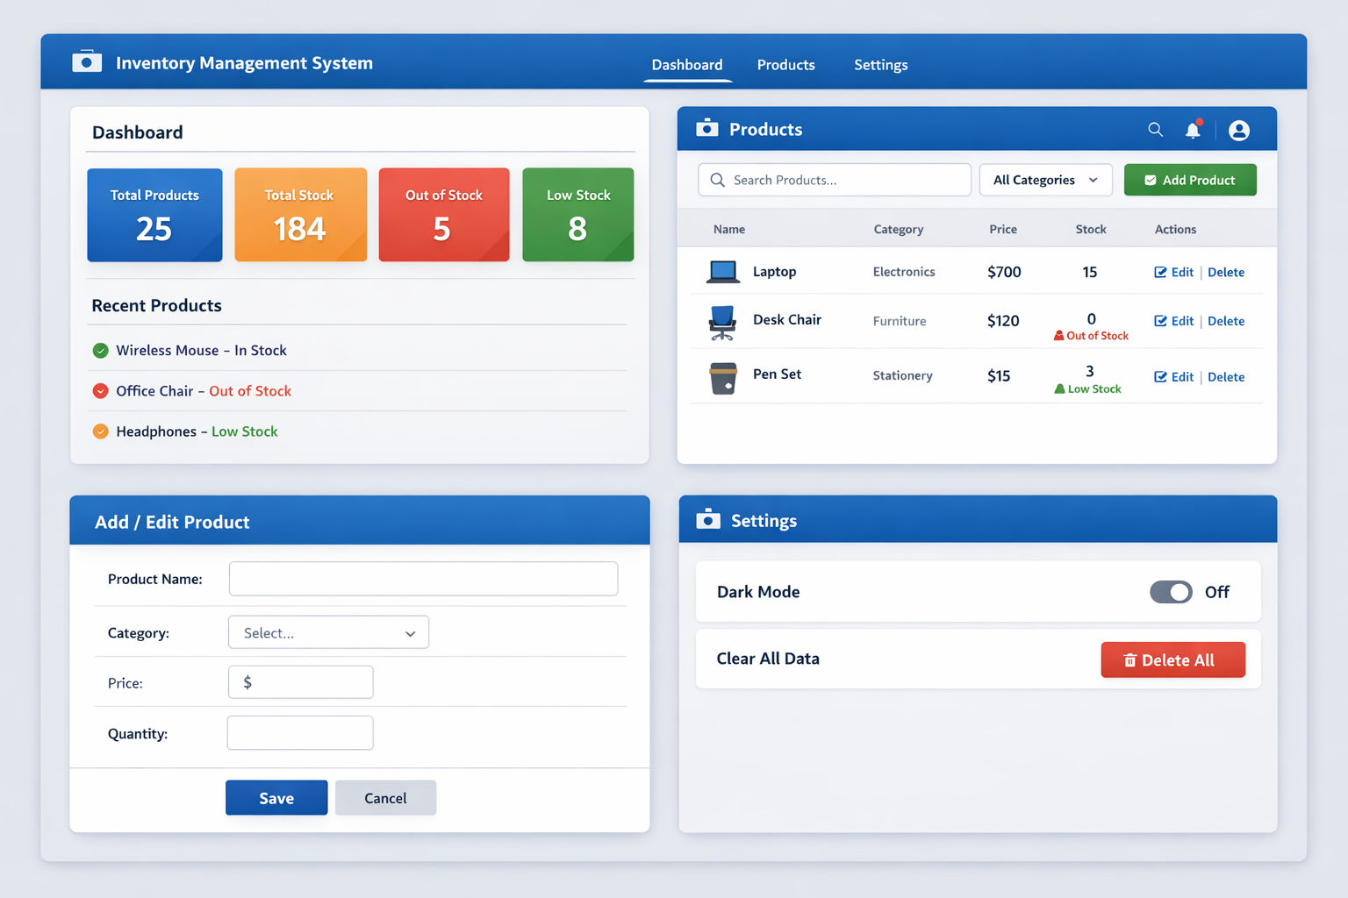

INVENTORY MANAGEMENT SYSTEM — UI WIREFRAME
Think of this like a mental picture before coding.

🖥️ 1️⃣ MAIN LAYOUT (Common for all pages)
------------------------------------
| Inventory Manager |
------------------------------------
| Dashboard | Products | Settings |
------------------------------------
|
| (Page Content Here)
|
------------------------------------

Explanation
- Top Bar → App title
- Navigation → Switch pages (React Router)
- Content Area → Changes based on page

📊 2️⃣ DASHBOARD PAGE
------------------------------------
| Dashboard |
------------------------------------
| [ Total Products ] [ Total Stock ]
| [ Out of Stock ] [ Low Stock ] |
------------------------------------
| Recent Products / Alerts |
------------------------------------

Cards Show:
- Total number of products
- Total quantity in stock
- How many are out of stock
- Low stock warning (e.g. < 5 items)
👉 No forms here — only calculated data

📦 3️⃣ PRODUCTS PAGE (MOST IMPORTANT)
------------------------------------
| Products |
------------------------------------
| Search: [________] Category ⬇️ |
------------------------------------
| + Add Product |
------------------------------------
| Name | Category | Price | Qty | ✏️ ❌ |
------------------------------------
| Mouse | Tech | 2000 | 10 | ✏️ ❌ |
| Chair | Furniture| 5000 | 0 | ✏️ ❌ |
------------------------------------

Key Elements
- Search by product name
- Filter by category
- Add product button
- Table showing all products
- Edit & Delete actions

➕ 4️⃣ ADD / EDIT PRODUCT FORM
------------------------------------
| Add Product |
------------------------------------
| Name: [___________] |
| Category: [Dropdown ▼ ] |
| Price: [___________] |
| Quantity: [___________] |
------------------------------------
| Save Cancel |
------------------------------------

Important
- Same form used for Add & Edit
- Controlled inputs (useState)
- Validation (empty fields ❌)

⚠️ 5️⃣ STOCK STATUS VISUAL CUES
Quantity | Status
0 | 🔴 Out of Stock
1–4 | 🟠 Low Stock
5+ | 🟢 In Stock
👉 Use color + text (interview bonus)

⚙️ 6️⃣ SETTINGS PAGE (Simple)
------------------------------------
| Settings |
------------------------------------
| 🌙 Dark Mode [ ON / OFF ] |
| 🗑️ Clear All Data |
------------------------------------
Optional but professional.

🧠 DATA MODEL (VERY IMPORTANT)
Each product should look like this:
{
id: 1,
name: "Mouse",
category: "Tech",
price: 2000,
quantity: 10
}
This will live in state + localStorage.

🧩 COMPONENT BREAKDOWN (MATCHES UI)
Component | Purpose
Navbar | Navigation
Dashboard | Stats
ProductTable | List products
ProductRow | Single product
ProductForm | Add/Edit
SearchBar | Filter
StatsCard | Dashboard card

🎯 WHY THIS WIREFRAME IS PERFECT
- Real-world
- Interview-ready
- Not over-complicated
- Scales well

🔥 NEXT STEP (Choose ONE):
1️⃣ Start project setup + routing
2️⃣ Build Products page first
3️⃣ Build Dashboard logic first
4️⃣ Start data model + state setup

